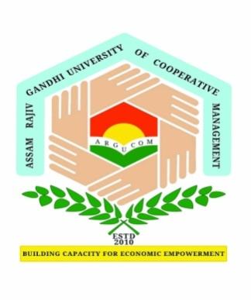
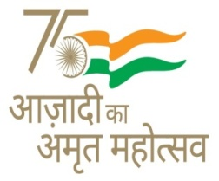
Assam Rajiv Gandhi University of Cooperative Management
(A Govt. of Assam University)
Recognised by UGC and member of Association of Indian Universities
Basic Tinali, Gadadhar Nagar, Joysagar, Sivasagar
Email: info.argucom@gmail.com

Course Work Registration Form - Ph.D.

Name of the Research Scholar :
(in Block letters)

Registration Number :

Mode of Admission
(Tick Appropriate box)
: Full Time
Part Time

Department :

S.  No | Course Code | Course Name | Course Credit
 |  |  | L | T | P

Payment Details | : | Amount of fees paid | Receipt No. | Date of Payment
 |  | `

Date: | Signature of the Research Scholar
Research Supervisor | Head of the Department
Remarks:

Dean (Academic)
Approved / Not Approved
 | Controller of Examinations

Encl: Photocopies of

- Provisional selection letter issued by the Registrar
- Syllabus for course work

